Informatica Project:

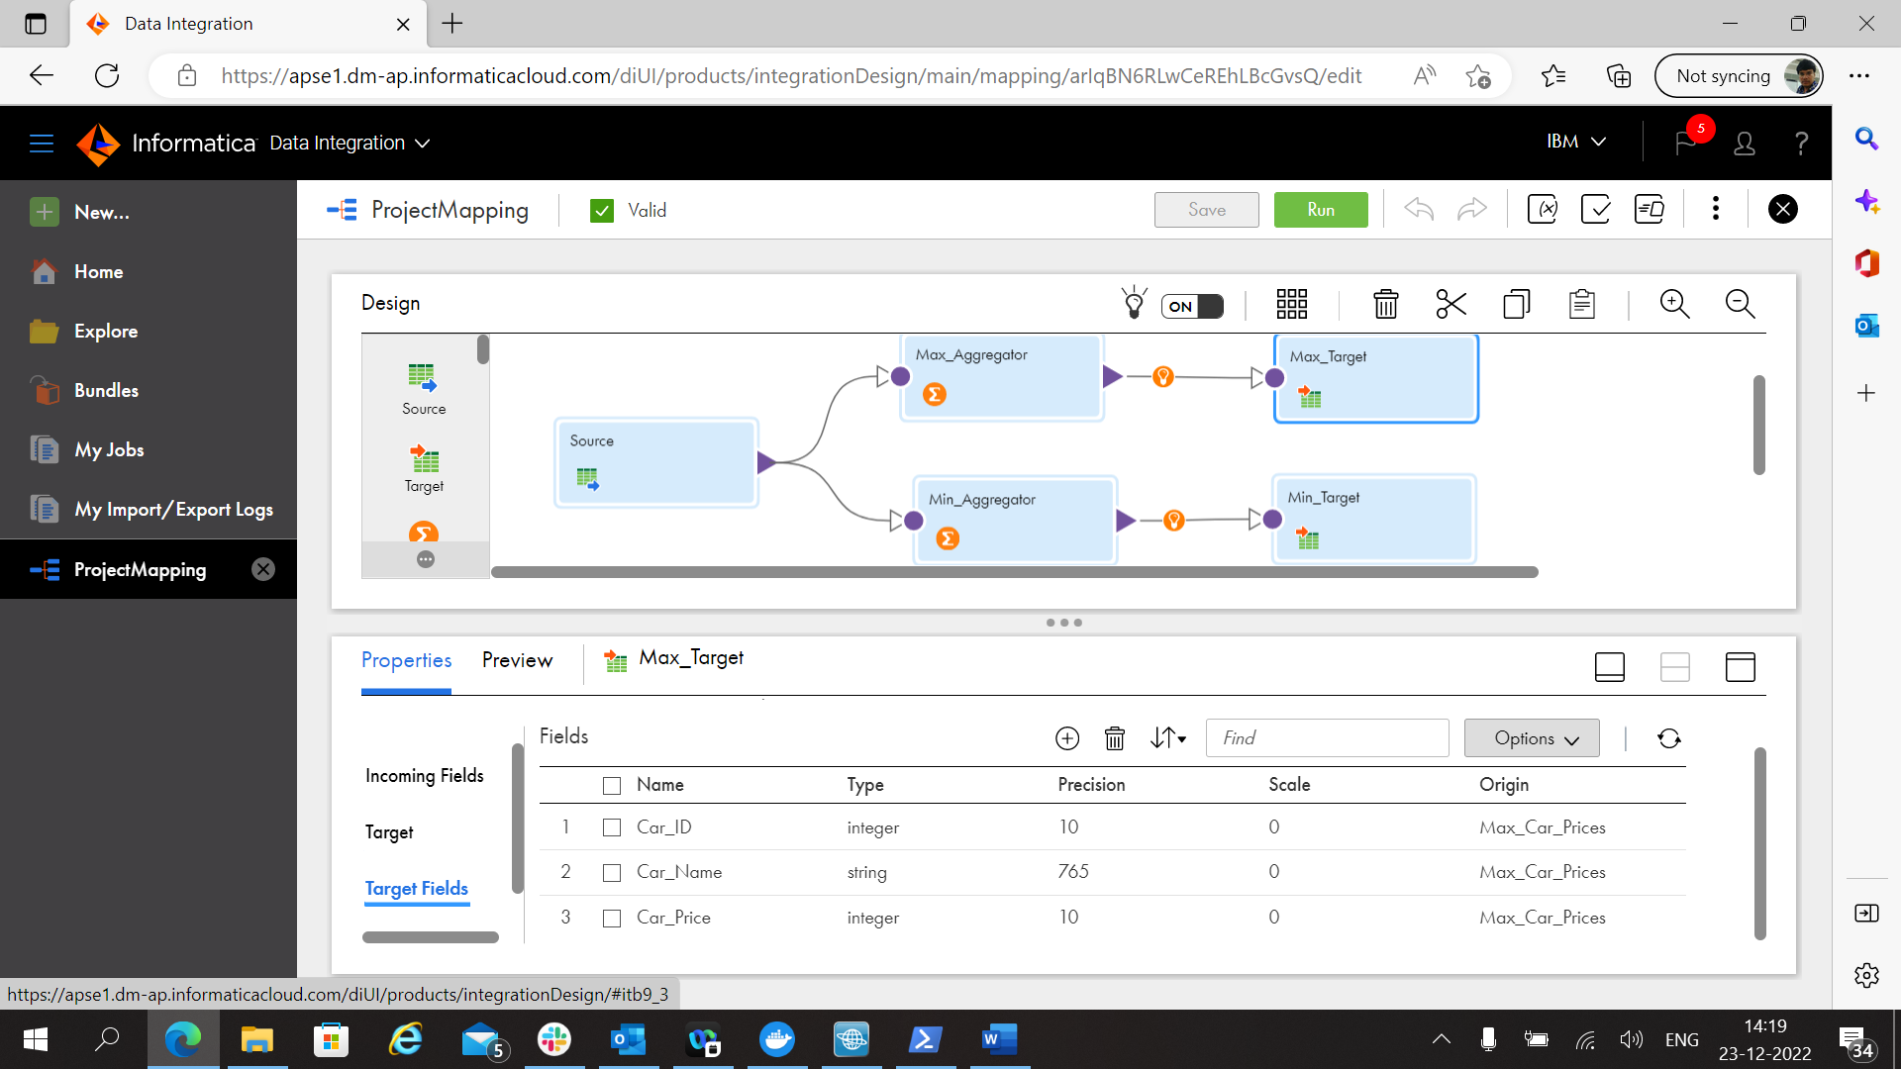

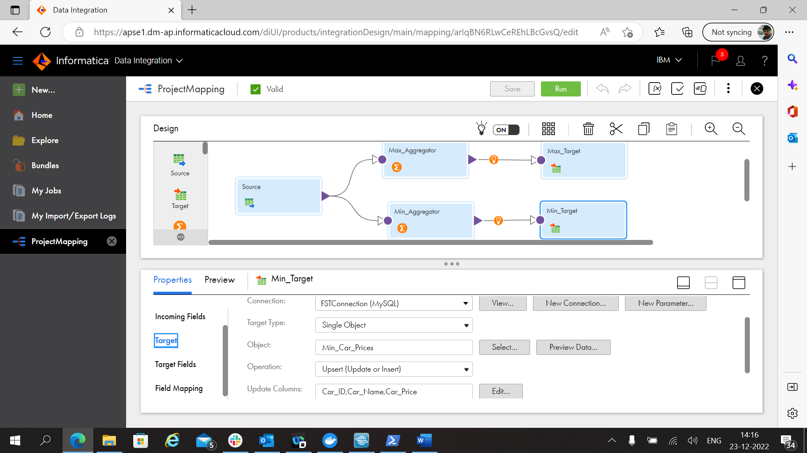

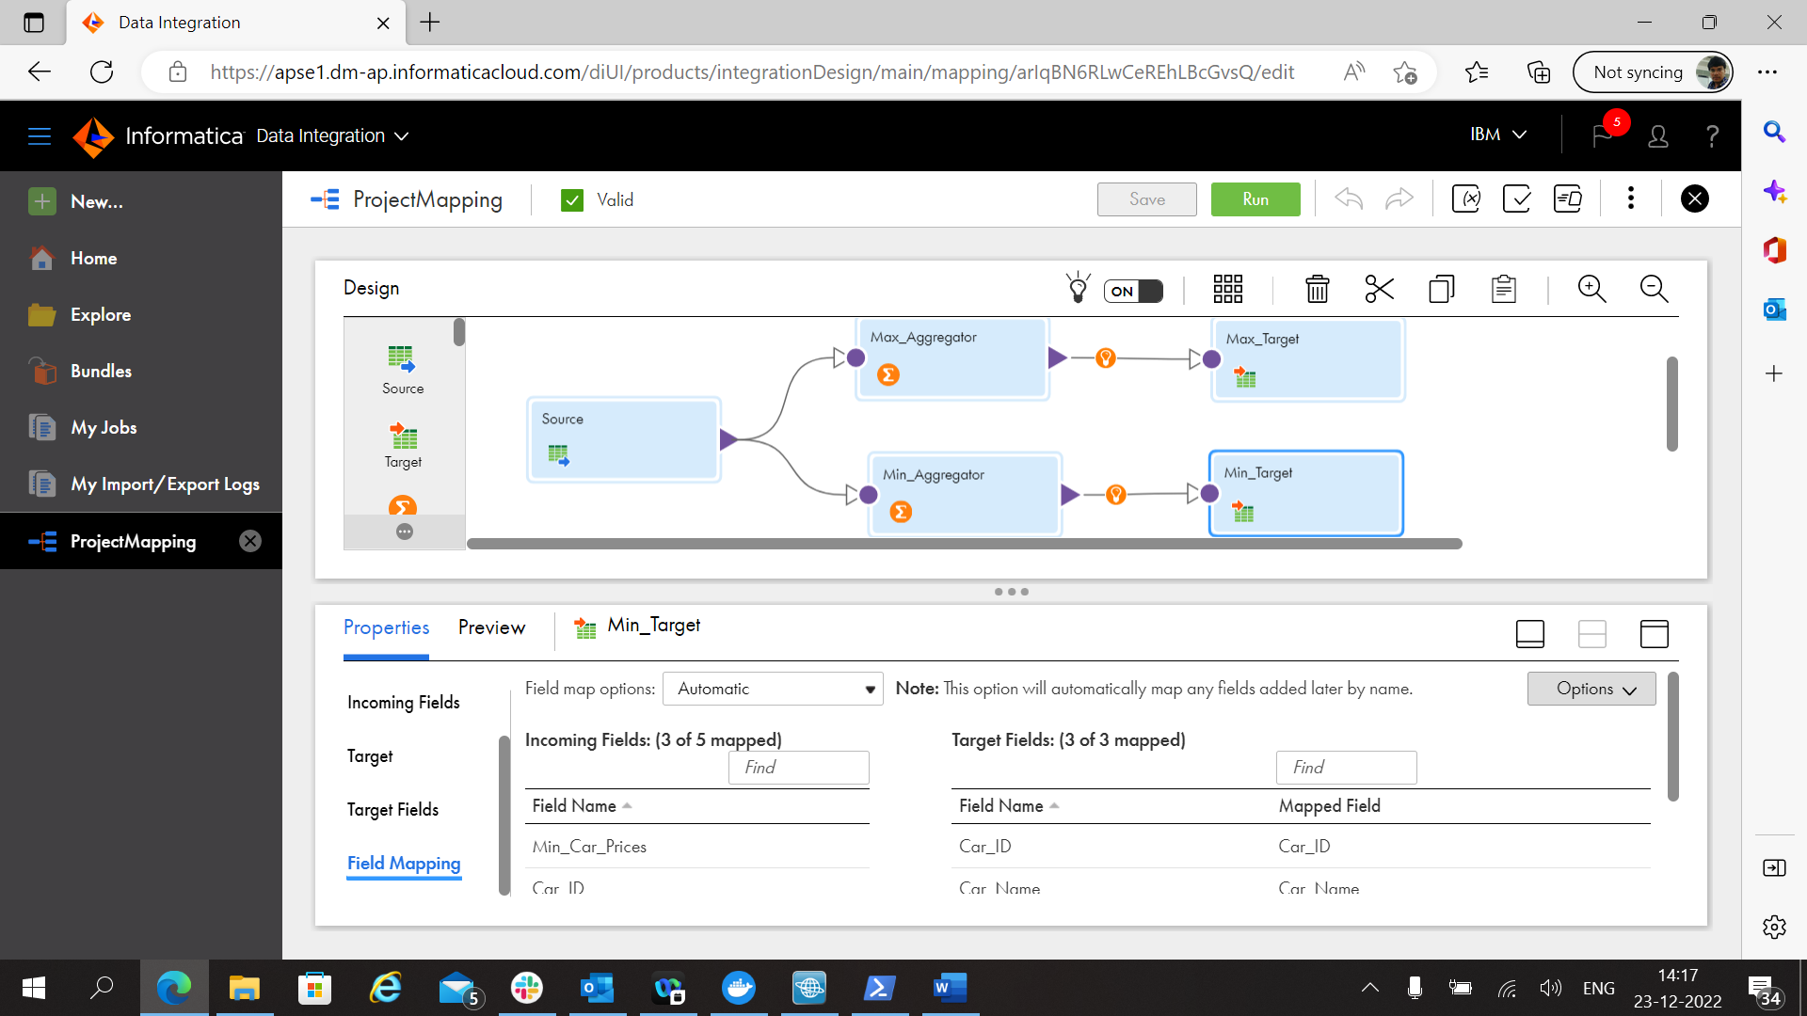

My Jobs:

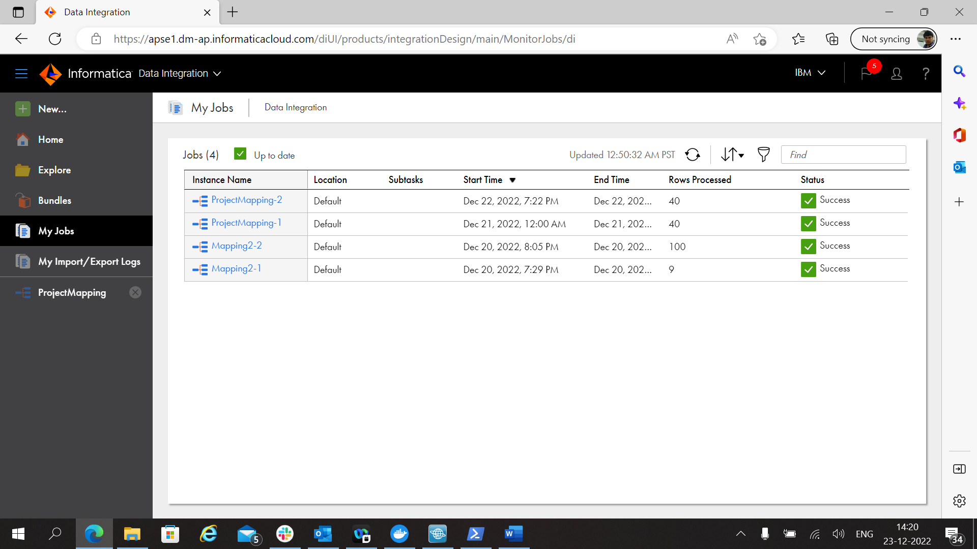

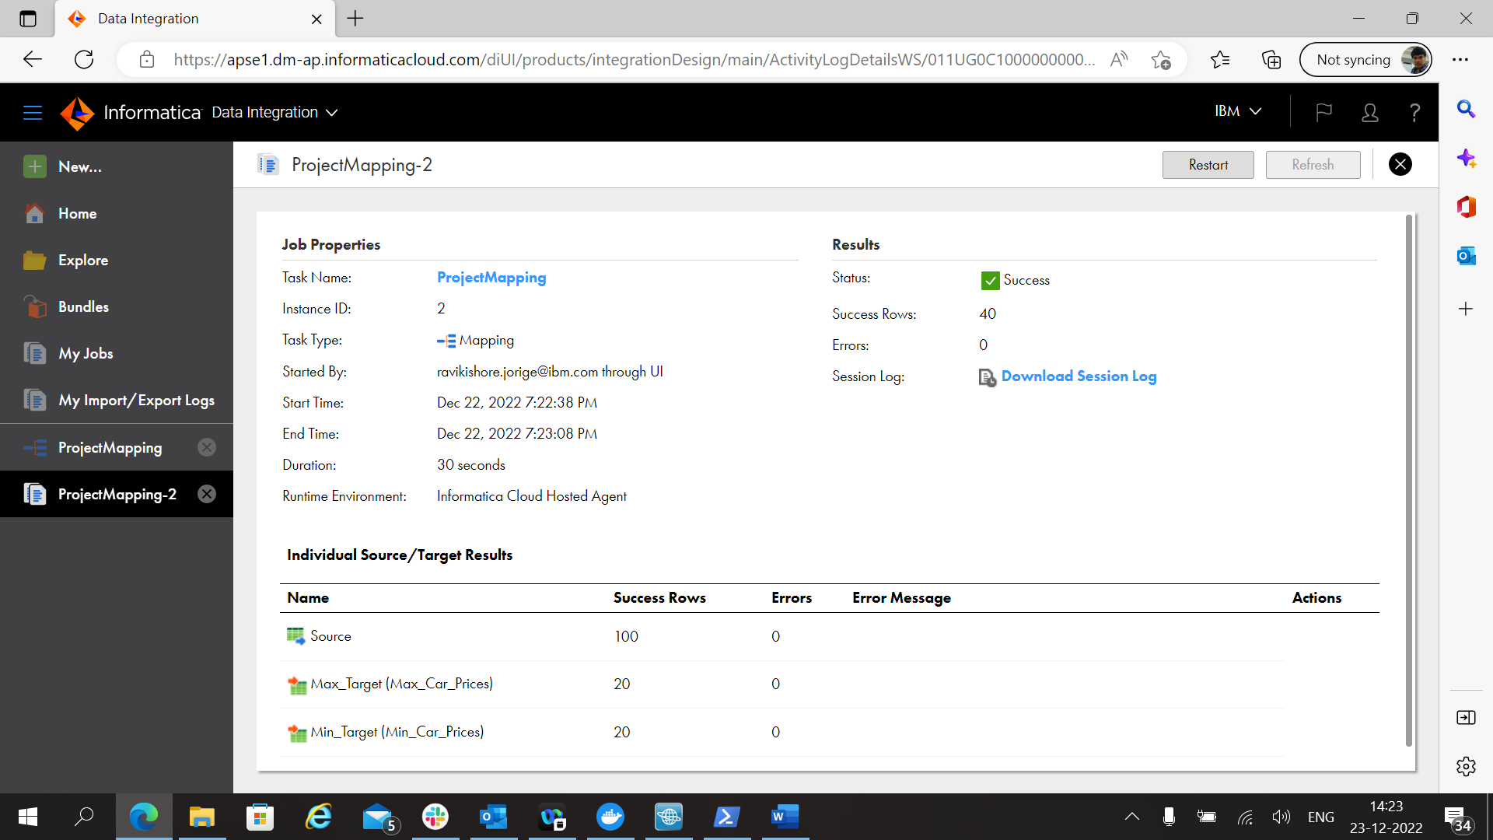

40 Rows Processed Successfully.